Classifying volcanoes
Volcanoes are classified according how to how they erupt. These 6 main types are listed below. They go form least explosive(Icelandic) to most explosive(Pelean)
1) Icelandic - This type of eruption emits large amounts of lava from fissures, often miles in length and spread in sheets over the land. The lava is very fluid and can flow for long distances. Forms low broad domelike cones.
2)Hawaiian - These eruptions come with lots of lava. These are rarely explosive, but fountains of lava can be shot up to 1,000 feet or more by jets of gas. The lava forms flat lava cones.
3) Strombolian These form moderate explosions accompanied by scoria and a white vapor cloud. Every so often, gases escape with small explosions, throwing scoria. They form Steep sided cones called cinder cones.
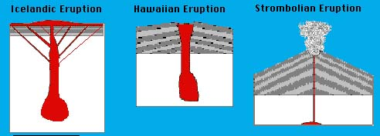
4 and 5) Plinian/Vulcanian. It forms a solid crust over the crater between infrequent eruptions. Accumulated gases then blow out these obstructions with strong explosions. Broken fragments, fresh lava, and scoria are hurled out of the crater. These eruptions come with a large “cauliflower-shaped” ash cloud. Forms steep sided and very symmetrical cones.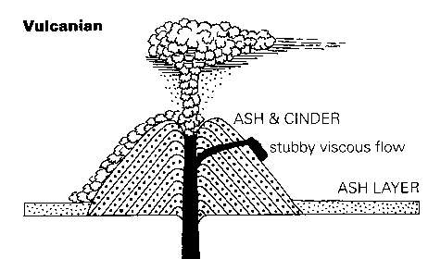

6) Peléan - greatest explosions. Its distinguishing feature is the nuée ardente, or “glowing cloud,” a highly heated gas charged with glowing ash particles that rushes down mountain slopes with hurricane force. The magma in these eruptions is usually blocked, so that explosions blast out horizontally beneath the plug.
Before eruption | When eruption
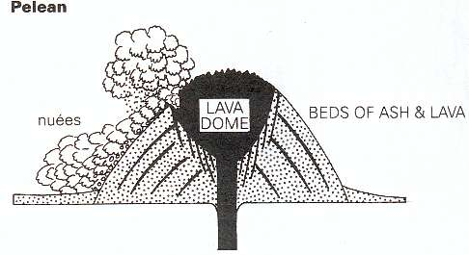 | 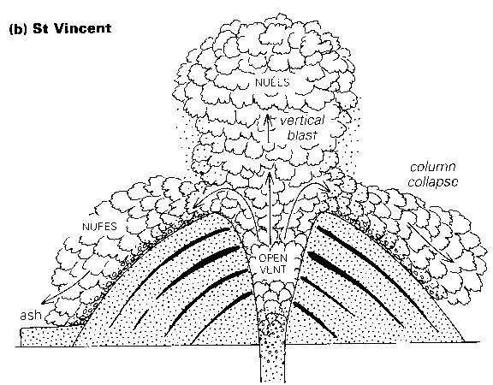
One of the most famous Pelean eruptions was Mount St Helens
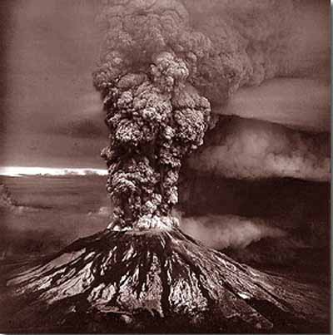

Complete this table.
Type of eruption | Cone shape formed | Relative force of explosion
Icelandic |  | Least  Most
Hawaiian |  | Least  Most
Strombolian |  | Least  Most
Plinian/Vulcanian |  | Least  Most
Peléan |  | Least  Most

